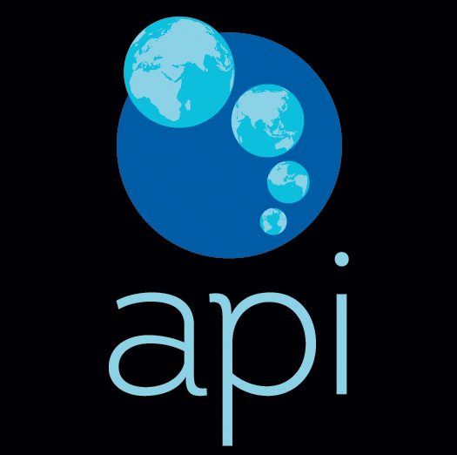

**API Strategy in the Cloud**



Theory of Cloud Computing B9IS120

Lecturer: John Rowley

Student Number: 10517074, 10380700, 10512558

Word Count: 3888

**Table of Content:**

EXECUTIVE SUMMARY 3

Management and Key Drivers for API Adoption 4

API Challenges 5

Scope, Scale, Standards 5

Technology, Teams, Governance 6

Security Risks 6

Monetization Challenges 7

API Management Platforms 7

Cloud vs On-Premises 7

Market Comparison 9

Role of API Management in delivering successful API programs 10

Examples of Successful API 11

API2Cart 11

The Facebook Graph 11

Google Map API 11

Twitter API 11

Building API Strategy 11

API Maturity Models 11

Business Values through APIs 13

API Business Models for Monetization - Strengths and Weaknesses 15

Building business value with the framework for API success 16

Business Strategy: Alignment and Usefulness 16

Engagement and Usability 16

Scalability and Evolvability 17

Manageability and Security 17

Conclusion 18

References 19

**Table of Figures:**

Figure 1API Management Market Trends (Abnewswire.com, 2018) 4

Figure 2 API adoption across companies (Accenture.com, 2018) 5

Figure 3 Gartner Research on Cloud Computing Security Threats (Securitycommunity.tcs.com, 2017) 6

Figure 4 Cloud vs On-premises (microsoft.com, 2015) 7

Figure 5 Design Time & Runtime (Ca.com, 2016) 8

Figure 6 API Platform On-premise vs. Cloud 8

Figure 7 Market Comparison of top 5 API management platforms (PAT RESEARCH: B2B Reviews, Buying Guides & Best Practices, 2019) 9

Figure 8 API MANAGEMENT MARKET COMPERISION (PAT RESEARCH: B2B Reviews, Buying Guides & Best Practices, 2019) 10

Figure 9 API Maturity Model (Accenture.com, 2013) 12

Figure 10 API Architecture Maturity Model (Rocha, 2019) 13

Figure 11 API Business models for Monetization 15

# EXECUTIVE SUMMARY



|  |  |  |  |
| --- | --- | --- | --- |
| **PROJECT TOPIC** | API Strategy in the Cloud Computing | | |
| **NAME OF STUDENTS** | Bhushan Chaudhari  Pavan Pardeshi  Eleonora Sadykova | **API ADOPTION ACROSS ORGANIZATIONS** |  |

|  |
| --- |
| **INTRODUCTION** |
| This report identifies the key drivers behind the growth of APIs in the cloud and the main challenges existing in API management. Additionally, market comparison of the leading API management platforms is provided and their role in overcoming existing challenges is stated. In the final section of the report the different business models of API monetization are considered and the API strategy framework is recommended to provide better API services. |
| **BACKGROUND** |
| APIs play an important role in cloud computing. APIs help to make the platforms more extensible, speed up the access and improve security management. The effective APIs strategy leads to the significant growth of organizations through innovations, cost reducing and increased performance. Implementation of successful API depends on the elaborating the right strategy for an organization: developing APIs for internal use, only for partners, for the general public or the combination of them. |
| **RESEARCH QUESTIONS** |
| 1. What challenges do organizations face within API adoption? 2. What strategy should organizations implement for effective API management? |
| **FINDINGS** |
| 1. APIs can help to reach business growth, efficiency and innovations. APIs support design modularity and compatibility. They are the main mechanism to connect technologies and organizations. 2. API management is accompanied by different challenges such as security, scalability, standards, lack of expertise, governance, monetization and many others. 3. In recent years variety amount of API management platforms have been emerging from the broad range of vendors, the purpose of which is to help to mitigate the risks of API development and implementation**: APIGEE, MuleSoft, 3Scale, Swagger Hub.** 4. API Strategy of an organization should include API maturity level assessment, business model selection and API management framework. |

# **Management and Key Drivers for API Adoption**

APIs exist for a long time, however, in the digital world, where the customers want to connect with the companies via various devices and channels the role of solutions which help to manage APIs and API –driven businesses significantly increased. API Management is the set of processes which control and improve the visibility of APIs that link applications and data across the enterprise and clouds. The main elements of API management solutions are a developer portal, an API gateway, API lifecycle management, analytics capabilities and support for API monetization (Apigee, 2019).

APIs today are the main mechanism for connection technologies and organizations. The companies who know how to implement them can reach significant growth, innovations, cut costs and increase efficiency. McKinsey forecasts increasing of public API soon (Iyengar et al., 2017). However, only a small amount of the organizations has a matured API program.

The increasing number of mobile subscribers, expanding social media and e-commerce stimulate the demand for API management. Other two main factors which flavouring global API management market are the Big Data and Internet of Things. API Management Market is expected to reach approximately 3 billion dollars by the end of 2022 with a compound annual growth rate 35% in the period between 2016 and 2022 (see Figure 1).



Figure 1API Management Market Trends (Abnewswire.com, 2018)

According to the Accenture’s survey, 71 % of the companies believe that API is a critical piece of their technology strategy. Companies were divided into three categories: leaders, strivers, and laggards (see figure 2). The companies mostly focus on microservices architecture, an essential part of which are APIs.

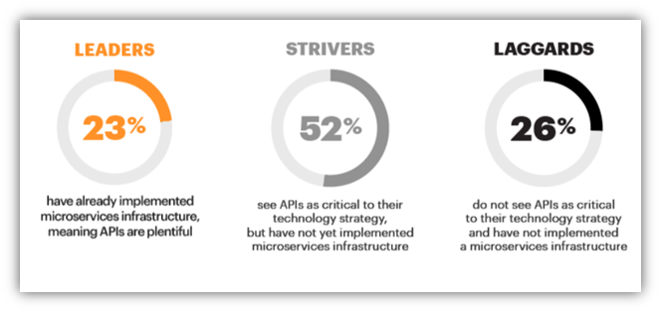

Figure 2 API adoption across companies (Accenture.com, 2018)

In the digital world, APIs are one of the key building blocks which support design modularity and compatibility. APIs support the idea that technology assets should be built for reuse. API help to achieve business agility, unlock new value in existing legacy systems and have operational and strategic benefits (Deloitte Insights, 2017).

# API Challenges

Importance of API Management has been increased in recent years. However, many challenges exist, among them: scope, scale, standards, technology, teams and governance, security issues, APIs monetization issues.

## Scope, Scale, Standards

One of the main challenges in API management is the proper level of central control. The number of teams who developing APIs consistently grows in a company. Each team has its own style, the point of view and experience. Without the guidelines which all teams share it is difficult to maintain consistency. Another issue is effectively dealing with changes over time. Keeping tracking hundreds or thousands of API entry points across different time zones and countries is not easy. Mature API program also should focus on standardizing interaction between APIs (Medjaoui et al., 2018, p.7-9).

## Technology, Teams, Governance

It is important to have a consistent set of tools and technologies on which you can rely on building an API management program. Initially, it can be a small set of tools, however, the right moment should be chosen to increase the variety of technologies when the number of APIs is scaling up. Another aspect of API management are teams. Expanding of API landscape also requires the number of people with the diverse set of skills. Updating and evolving governance documents is another important element of API management (Medjaoui et al., 2018, p.10-14).

## Security Risks

There are three main ways in which API security can be breached: parameter attacks, identity attacks and man in the middle (MITM) attacks. Parameter attacks use sending data to exploit weaknesses in applications and databases, such as SQL injection attack. Also, individual applications identify themselves to an API by using an API key, which in practice can be uncovered. Many APIs do not use properly SSL and TSL. This is one of the reasons for appearing of the risk when an attacker sites between an API and an application, catching the traffic between them (Rubens, 2019).

Currently, it is being seen an increasing number of attacks on businesses. APIs are used as a gateway to get access to the confidential information (see Figure 3).

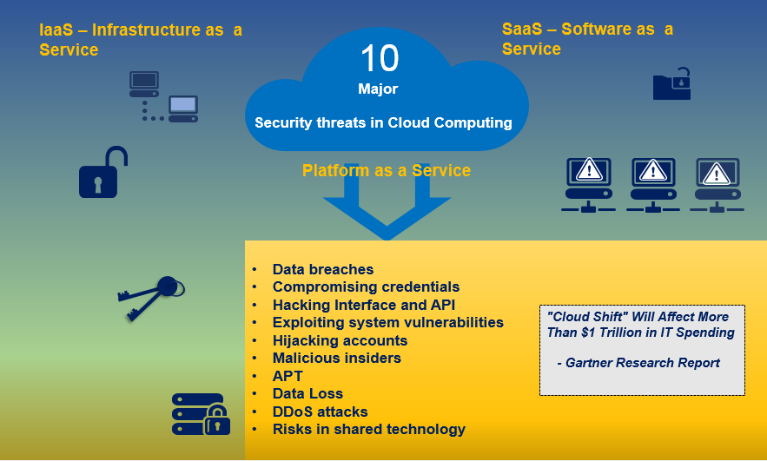

Figure 3 Gartner Research on Cloud Computing Security Threats (Securitycommunity.tcs.com, 2017)

For example, the social media tool Buffer identified that the hackers tried to access their systems via public API without authorization key. Businesses are not interested in having additional potential risks from open APIs (Boyd, 2015).

## Monetization Challenges

Another challenge is return on investment for public APIs. It is important to know how the benefits will be reached. To demonstrate a quick return on investment in case of public APIs is problematic. There are two growth curves for a public API. First growth period is establishing a strong community of developers is important you know how benefits will reach who integrate the API into their applications and web services. The second one is establishing own end-user customer base by these third – party applications (Boyd, 2015). The assets should be easily consumed through APIs and clearly correspond to its value proposition. Without this, APIs may struggle to gain adoption even if they were offered for free (Pages.apigee.com, 2019).

# API Management Platforms

## Cloud vs On-Premises

There are two options to deploy API management platforms (Figure 4).

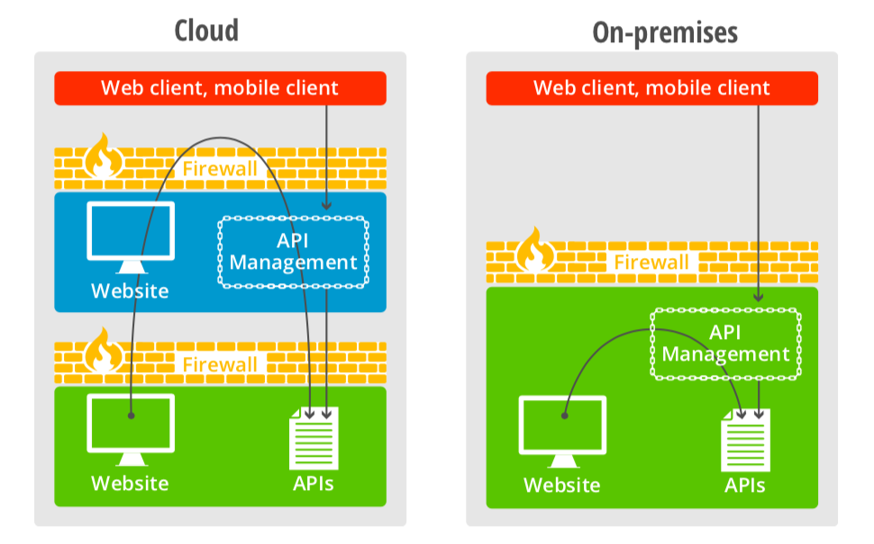

*Figure 4 Cloud vs On-premises (microsoft.com, 2015)*

The choice where to deploy is not always easy. API Management Platform can be considered from a usage model perspective which can be broken into phases: Design Time (API Portal) and Runtime (API Gateway). Design Time is a relation between API owners and users i.e. consumers regarding the service and business strategy. Runtime is the technical exchange of data where API backend is deployed on organizations infrastructure (Ca.com, 2016). Comparison of Design Time and Runtime is presented in Figure 5.

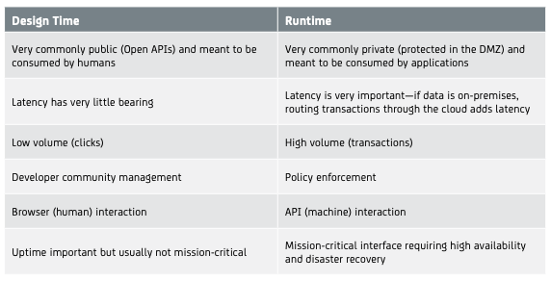

Figure 5 Design Time & Runtime (Ca.com, 2016)

Considering both phases of usage model and advantages of each deployment option the decision to deploy in the cloud or on – premises can be made (see Figure 6).

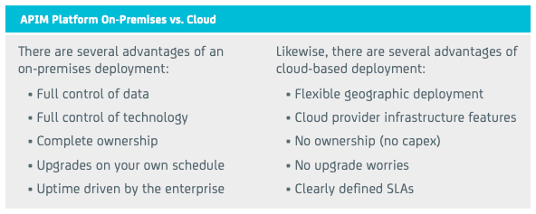

Figure 6 API Platform On-premise vs. Cloud

Making a decision regarding design time infrastructure deployment in the cloud or on – premises, the following should be considered: customization needs, security or costs. If a company needs an extensively customized developer portal, then on – premises might be a better choice. In a runtime environment many activities are mission – critical, the concerns about control and uptime exist. However, the company can choose the deployment in the cloud for its runtime infrastructure because of cost efficiency or no upgrade and other maintenance worries. For example, CA API Management solution offers both options of deployments as well as a hybrid one for an API Developer Portal and API Gateway components.

## Market Comparison

Among leaders on the market of API Management Solutions are APIGEE, MuleSoft, 3Scale and Swagger Hub (see Figure 7 and Figure 8).

Figure 7 Market Comparison of top 5 API management platforms (PAT RESEARCH: B2B Reviews, Buying Guides & Best Practices, 2019)

|  |  |
| --- | --- |
| **Apigee**  **The Cross-Cloud API Management Platform.**  **Cost:** Starting at $300 per month **License:** Proprietary Software **Market:** SMB/Enterprise **Delivery:** Proxy/Agent/Hybrid  **User Rating: 8.3**  **Editor Rating:** 7.6  **Category:** Predictive Analytics API  **Features**:   * Deploy within few clicks * Protect API & Engage User * Automate API operation * Expand platform | **MuleSoft**  **Connect anything. Change everything.**  **Cost**: Starting at $1200 per month **License**: Proprietary Software **Market**: Enterprise **Delivery**: Proxy/Agent/Hybrid  **User Rating:** 7.9  **Editor Rating:** 7.6  **Category**: Cloud  **Features**:   * Connect app, data & devices anywhere * Web-based dashboard for control * Design, run & analyse services and APIs * Mainstream java development tool |
| **3scale API Management**  **Future-proof API management.**  **Cost:** Starting at $50 per month **License:** Proprietary **Market:** Start-up/SMB/Enterprise **Delivery:** Proxy/Agent/Hybrid  **User Rating:** 8.1  **Editor Rating:** 7.6  **Category:** Backup Software  **Features:**   * API traffic control * Access control * Developers portal * Monetization tools * Authentication patterns & credentials | **Swagger Hub**  **The Platform for API Design and Documentation with OpenAPI.**  **Cost:** Free/ team $75 per month **License:** Proprietary  **Market:** Start-up/SMB/Enterprise **Delivery:** Proxy/Agent/Hybrid  **User Rating:** 9.5  **Editor Rating:** 7.6  **Category:** API Management Platform  **Features:**   * Automatic generation from the workflow * Real-time comments to communicate with collaborators and track open issue * Editor with smart syntax auto completion and smart error feedback |

Figure API MANAGEMENT MARKET COMPERISION (PAT RESEARCH: B2B Reviews, Buying Guides & Best Practices, 2019)

MuleSoft mostly specializes in the solutions for enterprises, while other 3 platforms offer management platforms for SMB and enterprises. Swagger Hub is a suitable option for startups as the system has good recommendations and has free offerings.

## Role of API Management in delivering successful API programs

As we know, the integration of multiple API is far more difficult than the integration of a single API. Therefore, most of the API management platforms provide solutions for few systems only, hence they miss out with the business opportunities. However, other platforms provide the solution for the group or multiple API management solutions and focus more towards business growth. Here’s a solution for this integrational difficulty without disturbing the quality and quantity of the API. There are several ways for the issue of API where vendors enable API to perform integration much faster, easier, cheaper as well as safer. API management platforms such as APIGEE, 3SCALE, IBM API MANAGEMENT , etc provide tools to build new cloud-based applications. It also provides better security(Softwaretestinghelp.com, 2019).

## Examples of Successful API

Among successful API examples are API2Cart, the Facebook Graph, Google Map API and Twitter API.

### API2Cart

If we take the example of API2Cart, it allows over 30 shopping carts to connect with customers and solves all integration problems to enhance the market value of carts. It provides 24/7 support, which is ready to help in every situation and protect customers data as well as store information from vulnerable activities due to which the customers get better security for their data. (Kholod, 2016) .

### The Facebook Graph

’The Graph API’ which is JSON-enabled. This allows to fetch and put the data from Facebook platform. This is the HTTP based API by which the apps can programmatically query data, users can post new stories and upload photos, manage ads and perform a wide range of tasks. (Facebook, 2019).

### Google Map API

Google maps are also one of the best API which has many different features and secured services. This is used to create maps, geolocate tweets, it is widely used for searching schools, hotels and so many different locations or to measure the distance (Jarmul, 2011).

### Twitter API

This API is mainly used by many journalists in order to get insights from Twitter. This is also a great platform for analysts who use it for a sentimental analysis of a data. The developers can use this API on any platforms as it provides an open source tool with better integrity (Jarmul, 2011).

# Building API Strategy

## API Maturity Models

To have just APIs in the company is not enough. There is a large difference between unstructured APIs and well-managed API program in the organization. The first step in building a successful API strategy is API maturity assessment. The level of maturity can be evaluated from different angles. According to Accenture’s maturity model, the company can be assessed against the following dimensions: strategy and governance, architecture, development process, developer community and optimization (see Figure 9).

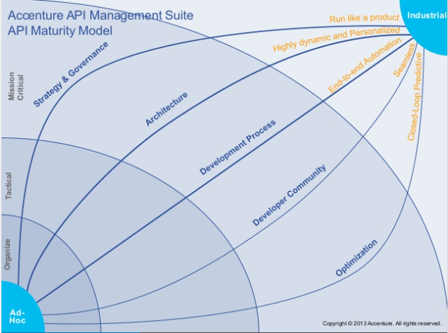

Figure 9 API Maturity Model (Accenture.com, 2013)

The API architecture maturity model consists of 7 levels (see Figure 10).

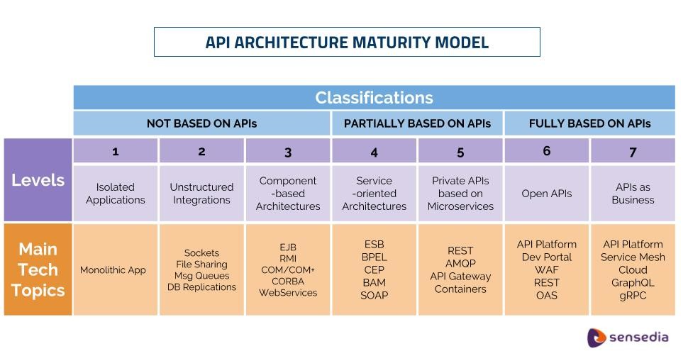

Figure 10 API Architecture Maturity Model (Rocha, 2019)

The organizations can be classified as not based on APIs at all, partially based on APIs, fully based on APIs. The companies with no APIs can have fully isolated systems or some level of integrations such as database replications, file sharing or component – based architectures. The main problem of this stage is the lack of compatibility between different technologies. Partially based on APIs companies have service - oriented architectures and private APIs based on Microservices. The main issue on this level that APIs are not fully managed. Also, the architecture is based only on single APIs gateway, that creates extensibility issue for an entire company. On the last two stages (6 and 7) APIs are part of the company’s business. APIs create new value streams and innovation services. On the top, 7 level, the business of the company fully depends on APIs, the good governance and compliance policies are implemented , the full capabilities of API platforms are used.

## Business Values through APIs

APIs are now valuable assets for business. There are five different ways which can convey an incentive to organizations (API Academy, 2015a):

* APIs help to generate revenue.
* It increases customer retention and market reach.
* It innovates business.
* API helps organizations to enable API integration.
* API helps organizations to support Internet of things (IoT).

In some cases, API’s can generate more revenue in the business. For example, the applications which provide mobile access to the e-commerce system as well as some online services, can help improve revenue sharing model with external developers to manufacture applications against the API. Here, the API must be worth or valuable to pay for or else clients can get the information from somewhere else and they do not need to pay for that. In such cases , Tiered Model is appropriate in which the developers get more users who pay for the required bandwidth which Tiered model provides.

Customer retention and market reach is also one of the factors which has to consider. This is mainly because the new online channels better understand the preferences of the targeted audience, in which API helps to reach up to them. Therefore, more personalized an experience or customer satisfaction leads to the improvement in customer retention. For example, nowadays most of the people use Google, Facebook, Twitter apps to seek information instead of browsing then for convenience. Hence, APIs can help to reach those customers.

API developers know the services which they provide through API. However, they do not know how the services are being used as well as how that can be used. Here comes the Open APIs which allows external developers to look at what is the best part of the particular API in combination with what they do best to make an innovative new idea. Therefore, by looking at the data and services through APIs, developers can analyse the interests, ideas as well as the interests of external developers as well as customers which can help to grow business more efficiently.

Organizations can integrate with each other that provides the services which are completely different and innovative through APIs. This allows them to focus on creating the new ideas from the combinations of services which they can provide through their newly generated API to the customers.

Internet of things provides a wide range of data such as smart applications, connected vehicles, RFID sensors and many more. Thus, APIs can integrate this huge set of data into a single and consolidated view. Furthermore, APIs can collect the data and provide a combination of the set of data from multiple locations which is related to the base information. Hence, in order to maximise the value of this dataset, APIs provide a platform to access the data through an analytical system.

## API Business Models for Monetization - Strengths and Weaknesses

There are seven common models for API monetization (Sandoval, 2018). The specifics of each of the model are presented in Figure 11.

|  |  |  |  |
| --- | --- | --- | --- |
| **API Business Model** | **Description** | **Strengths** | **Weaknesses** |
| API as a Business Function | Instead of direct monetization APIs provide benefits through enhancing core business functions (for example, reports with predictive insights) | Easier to monetize API - through improving business functions. To monetize API offering directly is hard sometimes due to competition. | Benefits are not transparent. |
| API as a Product | Direct monetization of APIs. The main condition of this model is the ownership of proprietary or valuable data. | One of the simplest models. | The cost is difficult to justify. Also, the model creates barriers for new users and limits the client base to premium users. |
| Layered APIs | Extension of the model ‘API as a Product’. The basic functionality is offered for free. However, for more data or more functionality, there is a fee. | If API providers have a clear line between free and paid services, then the effect of this model can be positive. | The main issue is transparency. Often, costs can become unpredictable. |
| API Interaction Measurement | Another extension for ‘API as a Product’. Charging is implemented based on the amount of interaction with APIs. | The companies can pay based on the amount of usage. It can be suitable for small companies. | All issues associated with freemium charging should be also considered here, including transparency. |
| API as a Marketing Tool | API is not a monetarized service itself. APIs offerings in this model are free and have a purpose to promote underlying systems and technologies (secondary monetarization) | This model can attract a solid client base, the way to advertise the rest of ecosystem of the company. | Can be a significant increase in operating expenses. Security and performance concerns exist. Also internally, it can be hard to show progress. |
| Strategic API Partnerships | Businesses collaborate with each other and create common add – ons , apps and integrations with APIs. | This model can be useful in creating new channels, expanding into an adjacent business. | The partner APIs should have the same level of security as for robust public APIs. It requires clear objectives, proactive management of the partners. |
| Value through Business Improvements | Monetization through optimizing prices and reducing the operational overhead for processes. | Savings pay for APIs itself. Monetizing APIs in this way can be essential. | Effective API management is required to receive a return on investments. |

Figure 11 API Business models for Monetization

As we can see, there are many challenges in ‘monetizing’ APIs. The different approaches exist. To choose the right one for the company is necessary to have an API strategy with clear objectives and outcomes. Often, a combination of the models is required.

## Building business value with the framework for API success

There are four main points focused on API methodology depending upon the components of API management, structure and design (API Academy, 2015b).

1. Business strategy: Alignment and Usefulness
2. Business Tactics: Engagement and Usability
3. Architecture: Scalability and Evolvability
4. Operations: Manageability and Security

### Business Strategy: Alignment and Usefulness

For delivering business values in a company, business strategy is very important and essential. Two key fundamentals required for implementing an API business strategy are discussed below:

1. Alignment of internal APIs must be done with the business goals of the organization.
2. Developer audience must be targeted with external APIs.

Once you have done with your strategy for aligning your API program together with your long - term business goals, it is time to start searching the kind of developer might be needed as a requirement of this strategy.

### Engagement and Usability

Two main guidelines always need to keep in consideration while deciding tactics for API developers:

1. Focus on engaging your target developers.
2. Make easy for these developers to use your APIs.

In order to keep engagement of the developers, it is necessary to provide them APIs which are in demand and easy – to – use. The tools which make development easy and reduce time cycles are also essential. To help your organization’s architects always make sure that the APIs they develop are developer friendly. You should collaborate with them to ensure how beneficial the APIs are and if they are capable to improve usability in the future.

### Scalability and Evolvability

In order to increase the chances of improvement of your organization, you must work closely with your developers, architects and your technical resources to keep ensuring they are designing, implementing and managing the decided strategies and tactics efficiently. The main reason behind this is your API must be scalable and evolvable i.e. it may be able to grow the business and adopting changes with requirements.

### Manageability and Security

The two essential principles to follow regarding manageability and security are:

1. An API’s activity should be easily seen and be controlled.
2. The data given by API must be right and for the right consumers.

These components can be conveyed most efficiently by an enterprise-grade API management platform, a complete structure that can fit into your organization while providing full functionality and ability to manage itself with high terms of security as well.

Albeit there are no unified API standards for any industry, some steps in this direction are applied (Developer.ibm.com, 2016). The European Commission has issued the requirements for Financial industry – Payment Services Directive 2. The USA has some regulations in the Healthcare industry to promote using APIs for access to patient-related information. Also, the government of the UK published API technical and data standards to help your organization to provide high – quality services to users (GOV.UK, 2018).

# Conclusion

APIs are connecting technologies and organizations. The role of APIs in providing growth and innovations to companies has been increasing. However, business value can be guaranteed only in case of effective API Management. Organizations should understand that the key to successful using of APIs is clear objectives and outcomes, and, also the right tools. The main questions needed to address before developing APIs are:

1) What API maturity level has a company?

2) What are the business objectives? And what business model is going to use a company for ‘monetizing’ APIs?

3) How to overcome different APIs challenges? To choose the right API Management Platform, either a combination of tools.

4) What are assessment activities for evaluation of the effectiveness of the API program in a company?

# References

Abnewswire.com. (2018). ‘API Management Market 2018 Global Regional Analysis, Upcoming Trends, Industry Segments, Landscape, Top Key Players and Size by Forecast to 2022 – ABNewswire – Press Release Distribution Service – Paid Press Release Distribution Newswire’. Available at: http://www.abnewswire.com/pressreleases/api-management-market-2018-global-regional-analysis-upcoming-trends-industry-segments-landscape-top-key-players-and-size-by-forecast-to-2022_298483.html (Accessed: 25 March 2019).

Accenture.com. (2013). ‘API Maturity Model – Accenture'.Available at: https://www.accenture.com/us-en/service-api-maturity-model (Accessed: 2 April 2019).

Accenture.com. (2018). ‘Cloud Partnering Proposition: APIs and Microservices | Accenture’. Available at: https://www.accenture.com/us-en/insights/strategy/cloud-partnering-proposition (Accessed: 25 March 2019).

API Academy. (2015a). ‘API Strategy 102: The Business Value of APIs’. Available at: https://www.apiacademy.co/lessons/2015/04/api-strategy-lesson-102-the-business-value-of-apis (Accessed: 5 April 2019).

API Academy. (2015b). ‘Building Business Value with APIs’. Available at: https://www.apiacademy.co/lessons/2015/10/api-strategy-lesson-203-building-business-value-with-a-framework-for-api-success (Accessed: 5 April 2019).

Apigee. (2019). ‘What Is API Management?’. Available at: https://apigee.com/about/cp/what-api-management (Accessed: 25 March 2019).

Boyd, M. (2015). ‘Developing the API Mindset’. *Nordic APIs.* Available at: https://19yw4b240vb03ws8qm25h366-wpengine.netdna-ssl.com/wp-content/uploads/developingtheapimindset.pdf (Accessed: 25 March 2019).

Ca.com. (2016). ‘Deploying Your API Infrastructure: Cloud, On-Premises or Both?’ Available at: https://www.ca.com/content/dam/ca/us/files/solution-brief/deploying-your-api-infrastructure.pdf (Accessed: 5 April 2019).

Deloitte Insights. (2017). ‘API imperative: From IT concern to business mandate*’*. Available at:https://www2.deloitte.com/insights/us/en/focus/tech-trends/2018/api-program-strategy.html (Accessed: 25 March 2019).

Developer.ibm.com. (2016). ‘API Industry Standards and Regulatory Requirements - API Connect’. Available at: https://developer.ibm.com/apiconnect/2016/01/21/api-industry-standards-and-regulatory-requirements/ (Accessed: 4 April 2019).

Facebook. (2019). ‘Facebook for developers’.  
Available at: https://developers.facebook.com/docs/graph-api/overview/  
(Accessed: 1 April 2019).

GOV.UK. (2018). ‘API technical and data standards’. Available at: https://www.gov.uk/guidance/gds-api-technical-and-data-standards (Accessed: 4 April 2019).

Iyengar, K., Khanna, S., Ramadath, S. and Stephens, D. (2017). ‘What it really takes to capture the value of APIs’*. McKinsey & Company.* Available at: https://www.mckinsey.com/business-functions/digital-mckinsey/our-insights/what-it-really-takes-to-capture-the-value-of-apis (Accessed: 25 March 2019).

Jarmul, K. (2011). ‘How to use APIs from Twitter, Google & Facebook to find data, ideas’. *Poynter*. Available at: https://www.poynter.org/reporting-editing/2011/how-to-use-apis-from-google-facebook-twitter-to-find-data-ideas (Accessed: 5 April 2019).

Kholod, A. (2016). ‘API2CART’.  
Available at: <https://api2cart.com/business/6-difficulties-api-integration-way-avoid/> (Accessed: 5 April 2019).

Medjaoui, M., Wilde, E., Mitra, R. and Amundsen, M. (2018). *Continuous API management*. 1st ed. o'Reilly Media.

Microsoft.com. (2015). ‘Cloud-based API Management: Harnessing the Power of APIs’. Available at: http://download.microsoft.com/download/6/F/1/6F197BB5-F46E-4678-92DF-5A32ECD6F18D/microsoft_azure_api_management_white_paper_20150520.pdf (Accessed: 1 April 2019).

Pages.apigee.com. (2019). ‘Maximizing the Business Value of Digital Assets Through API Monetization’. Available at: https://pages.apigee.com/rs/351-WXY-166/images/apigee-monetization-ebook.pdf (Accessed: 5 April 2019).

PAT RESEARCH: B2B Reviews, Buying Guides & Best Practices. (2019). ‘Top 27 API Management Platforms - Compare Reviews, Features, Pricing in 2019 - PAT RESEARCH: B2B Reviews, Buying Guides & Best Practices’. Available at: https://www.predictiveanalyticstoday.com/top-api-management-platforms/ (Accessed: 5 April 2019).

Rocha, R. (2019). ‘API Architecture Maturity Model – Sensedia'. *Sensedia*. Available at: https://sensedia.com/en/blog/apis-en/api-architecture-maturity-model/ (Accessed: 2 April 2019).

Rubens, P. (2019). ‘How to Control API Security Risks’. *Esecurityplanet.com*. Available at: https://www.esecurityplanet.com/applications/api-security.html (Accessed: 25 March 2019).

Sandoval, K. (2018). ‘7 Types Of API Business Models | Nordic APIs |’. *Nordic APIs*. Available at: https://nordicapis.com/7-types-of-api-business-models/ (Accessed: 2 April 2019).

Securitycommunity.tcs.com. (2017). 10 Major Security Threats in Cloud Computing | TCS Cyber Security Community. Available at: https://securitycommunity.tcs.com/infosecsoapbox/articles/2017/02/14/10-major-security-threats-cloud-computing (Accessed: 4 April 2019).

Softwaretestinghelp.com. (2019). ‘Top 10 Best API Management Tools with Feature Comparison’. Available at: https://www.softwaretestinghelp.com/api-management-tools/ (Accessed: 5 April 2019).

**Acknowledgement:**



Kindly Note – All 3 team members have actively participated and contributed equally to this assignment.

Students:

1. **Bhushan Chaudhari – 10517074**
2. **Eleonora Sadykova – 10512558**
3. **Pavan Pardeshi – 10380700**